Autonomous Mobile Robot Navigation: Implementing Three Key Behaviours

Oke Iyanuoluwa Enoch
@00659936
Lecturers: Dr Salem Ameen & Prof Mary He
Module Title: Mobile Robotics
Programme: MScs. Robotics and Automation
School of CSE, University of Salford, Manchester M5 4WT, UK
i.e.oke@edu.salford.ac.uk

Abstract - This study investigates the implementation of three pivotal behaviors odometry model for waypoint following, target tracking, and obstacle avoidance essential for the autonomous navigation of mobile robots in dynamic environments. Utilizing the Pioneer P3-DX robot, the research integrates these behaviors into a cohesive navigation system that enhances robotic autonomy, efficiency, and safety. The odometry model facilitates precise waypoint navigation, target tracking enables the robot to follow moving objects accurately, and the obstacle avoidance algorithm ensures safe navigation around unforeseen obstacles. Experimental results validate the effectiveness of the combined behaviors, demonstrating significant improvements in autonomous mobile robot navigation.
Index Terms - Autonomous Mobile Robots, Obstacle Avoidance, Target Tracking, Waypoint Following, Navigation Systems.
- Introduction
Autonomous mobile robot navigation stands at the forefront of robotics research, serving as a pivotal domain dedicated to the development of robots capable of autonomously navigating through dynamic and often unpredictable environments. Within this expansive field, this journal report zeroes in on a crucial aspect: the implementation of three key behaviors essential for tackling the tracking problem in autonomous navigation.
The impetus behind this investigation stems from a burgeoning demand across diverse industries for resilient robotic navigation systems. Industries ranging from manufacturing and logistics to healthcare and agriculture increasingly rely on autonomous robots to streamline operations and enhance efficiency. Consequently, there exists a pressing need to equip these robots with robust navigation capabilities that enable them to navigate safely and efficiently in real-world scenarios.
To address this need, the study adopts an integrative approach that melds theoretical frameworks with practical applications. Drawing upon insights from robotics, artificial intelligence, and control theory, the methodology revolves around the design and implementation of a comprehensive framework. This framework empowers autonomous robots to adeptly track dynamic targets in real-time, thereby bolstering their navigational prowess.

Central to the research endeavor is the primary objective of enhancing the autonomy, adaptability, and safety of robotic systems. By endowing robots with the requisite capabilities for reliable navigation, the study aims to usher in a new era of autonomous robotics marked by heightened efficiency and effectiveness.
The contributions of this research are manifold. Notably, it presents a holistic framework for implementing key navigation behaviors, underpinned by empirical evidence of its efficacy garnered through extensive experimentation. Beyond merely advancing the state-of-the-art in robotics, this study offers tangible solutions with practical implications for industries reliant on autonomous robotic systems. In doing so, it effectively bridges the gap between theoretical advancements and real-world applications in the realm of autonomous mobile robot navigation.
Furthermore, throughout this report, the Pioneer P3-DX robot was used to develop and validate the suggested Odometry model for waypoint following, Target tracking for approaching recognized targets, and an obstacle avoidance framework.

- Literature Review
Pandey Anish et al. addresses the challenge of evaluating techniques for mobile robot navigation and obstacle avoidance across diverse environments. They categorize these techniques into deterministic, non-deterministic, and evolutionary algorithms, including Voronoi diagrams, artificial potential fields, and genetic algorithms. The key findings reveal a prevalence of soft computing methods in static environments, with limited exploration in dynamic settings and an overreliance on simulation-based results. Future research should prioritize implementing and testing proposed techniques on physical robots to validate their efficacy against existing methods. Furthermore, there is a call for developing more robust algorithms capable of handling uncertainties and evolving environmental conditions, particularly in scenarios involving noisy sensors and multi-robot coordination.

Patrick Benavidez et al. presents a framework addressing the challenge of costly and scalability-limited systems by proposing a navigation and target tracking system for mobile robots utilizing a low-cost 3D depth and colour sensor, the Microsoft Xbox Kinect. Techniques employed include fuzzy logic for obstacle avoidance and target tracking control, alongside neural networks for pattern recognition, object tracking, and path planning, supplemented by remote server integration for data collection and supervisory feedback. It details the dynamic model of a differential drive robot, image recognition methods, fuzzy rule generation, and object tracking design. Findings highlight the advantages of Kinect sensor and remote server usage. Recommendations for improvement involve real robot testing, comparative analysis with existing methods, and exploration of additional sensors and data fusion techniques to address outdoor environmental challenges.

Walead Kaled et al. addresses the challenge of enabling mobile robots to autonomously explore unknown indoor environments affordably, employing low-cost sensors and deep learning techniques. Techniques utilized include monocular vision with deep neural networks, stereo camera calibration, convolutional neural networks (CNNs) with SoftMax layers, and hand-controlled mobile robot (HCMR) data collection. Key findings reveal the proposed model achieving 77% accuracy in obstacle avoidance and navigation decisions using depth images from stereo web cameras. Additionally, the model exhibits human-like behaviours and learns from diverse environments, as evidenced by similar decision-making patterns compared to humans. Recommendations for improvement include refining offline training methods, enhancing data quality and diversity, integrating localization and mapping systems, and transitioning from discrete to continuous control commands.

Chi-Wen Lo et al. tackles the challenge of devising an intelligent control system for mobile robot navigation tasks in surveillance, encompassing moving target pursuit, obstacle avoidance, and wall following. It introduces a novel autonomous and intelligent controller amalgamating reinforcement learning, fuzzy logic, and Kalman filtering. Reinforcement learning aids in selecting appropriate fuzzy rules for cost-based navigation, while the Kalman filter estimates the trajectory of moving targets for pursuit. Simulation and experimental results validate the system's effectiveness, demonstrating successful wall following, obstacle avoidance, and target pursuit in unknown environments. Future enhancements could focus on improving computational efficiency, enhancing generalization capabilities, and testing the system in more complex navigation scenarios, such as capturing moving targets.

Xueling Luo et al. addresses the challenge of creating an intelligent system for real-time tracking and following of a moving human target by a mobile robot, utilizing a depth camera and laptop setup. Techniques employed include an improved kernelized correlation filter (KCF) for visual tracking in RGB images, an extended Kalman filter (EKF) for 3D motion prediction using depth data, a mecanum wheeled omnidirectional robot for agile movement, and a depth-based obstacle avoidance algorithm for safe navigation. Findings demonstrate the system's reliable tracking and following capabilities across various scenes, handling target occlusion, scale variation, and illumination changes while effectively avoiding obstacles. Areas for improvement include enhancing performance during fast target motion, increasing robustness to depth camera noise, and enhancing scalability and adaptability to diverse targets and environments.

Ratchatin C. et al. tackles the challenge of real-time motion planning and obstacle avoidance for an autonomous mobile robot capable of tracking a target while avoiding collisions with walls or forbidden areas. Utilizing low-resolution optical sensors and an electronic compass, the robot switches between target tracking and wall following modes based on obstacle proximity. A simple control algorithm balances sensor signals to adjust robot orientation and distance from obstacles. Findings demonstrate the technique's simplicity and efficiency in handling various scenarios, including circular obstacles, mazes, forbidden areas, and moving obstacles, while integrating with different guidance modes. Areas for improvement include providing detailed experimental setup information, comparative analysis with existing techniques, and addressing limitations regarding sensor noise sensitivity and scalability in complex environments.

Boyoon Jung et al. addresses the challenge of estimating the positions and velocities of multiple moving objects in dynamic outdoor environments using a mobile robot equipped with a monocular camera and a laser rangefinder. Techniques employed include ego-motion compensation using the KLT(Kanade-Lucas-Tomasi) algorithm, motion detection and tracking via adaptive particle filtering, and multiple motion tracking with particle clustering. Findings indicate robustness in coping with various ego-motions and successful tracking of multiple objects, demonstrating real-time capability. Areas for improvement include enhancing robustness in feature selection and matching, refining transformation models for improved accuracy, and optimizing particle filtering efficiency and adaptability to diverse motion models and convergence speeds.

L. Huang et al. addresses the challenge of controlling a wheeled mobile robot to track a moving target within limited control inputs, crucial in practical scenarios where unpredictable target motions may exceed the robot's capabilities. It proposes a Lyapunov-based controller design approach to determine the robot's velocities, ensuring asymptotic convergence of tracking errors while considering input limitations. The controller's effectiveness in successfully tracking the target under specific conditions is demonstrated through simulations, with analysis of system responses and trajectory paths. Areas for improvement include addressing practical issues like minimum angle tracking error thresholds, modifying the controller for unmet conditions, and enhancing robustness to uncertainties and disturbances, alongside comparative analysis with existing methods and expanded simulation examples or experimental results.

Qazwan Abdullah et al. aimed to develop a mobile robot capable of autonomously locating, tracking, and following a moving object using a vision system. Techniques employed include image processing algorithms like color filtering, circular shape detection, center of gravity calculation, and serial communication. Findings reveal successful detection and tracking of a tennis ball based on color and shape, with the robot adjusting motion and orientation accordingly. It can also search for the ball if it exits the camera's view and enact appropriate responses based on proximity. Areas for improvement include enhancing the vision system's robustness to lighting conditions and object colors, improving image processing speed and accuracy, reducing power consumption and weight, and integrating additional sensors and navigation techniques.
Muhammad Shaikh et al. addresses the challenge of vision tracking for mobile robots through sensor fusion and localization techniques, aiming to accurately determine the robot's position and orientation while dynamically rotating the camera towards the target during locomotion across diverse environmental conditions and motion scenarios. Techniques involve employing two Kalman filters; one for slip and one for no-slip cases, to integrate information from encoders, inertial sensors, and active beacons. Findings from experiments assessing system performance across various robot motions and scenarios demonstrate significantly reduced position errors and successful target tracking. Improvements could involve incorporating vision sensor data for tracking, extending the system to three-dimensional motion, and enabling multiple target tracking.

Lee M.F & Lee H.E addressed the real-time tracking and following of a moving target with an autonomous mobile robot in an unstructured and unknown environment, utilizing techniques such as Bayes’ theorem-based segmentation for motion detection, color-based particle filter algorithm for object tracking, and fuzzy logic combined with sensor data fusion for obstacle detection to mitigate ultrasonic phantom effects. The main findings indicate that the system achieved tracking accuracy exceeding 80% and successfully tracked and followed a moving target while navigating around obstacles in real-time. The paper suggests potential improvements in enhancing tracking flexibility and accuracy, as well as integrating a PTZ camera into the mobile robot system to provide full tracking coverage and reduce computational load for continuous motion detection.

Xiaoyu Guo et al. addresses the issue of intelligent mobile robots frequently losing track of targets due to changes in appearance during tracking, utilizing the Caffe deep learning framework and ROS robot operating system to implement a target tracking system based on the GOTURN algorithm, which achieves effective tracking in various scenarios with high accuracy, real-time performance, low cost, and easy scalability, with potential enhancements suggested such as expanding the training set and adapting the tracking model to specific target types.

Douglas Henke et al. addresses the navigation problem of a mobile robot utilizing vision systems to identify obstacles is addressed, employing the YOLO algorithm for object recognition and RGBD images from a Microsoft Kinect sensor for distance measurement, yielding reliable obstacle detection by the YOLO network and distance calculation with Kinect's depth information exhibiting an error below 3.64%, with future improvements suggested such as integrating Kinect data with other sensors like ultrasonic sensors for enhanced navigation robustness and enhancing the neural network's performance and the robot's obstacle avoidance accuracy.

- Methods
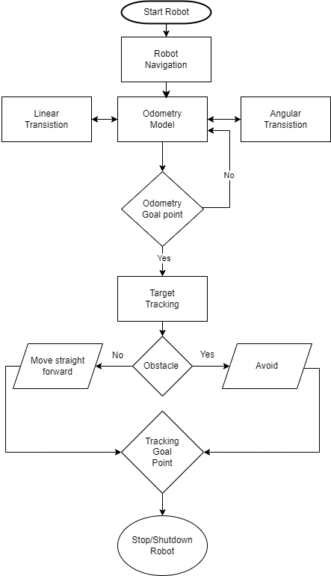
The proposed intelligent system architecture for Autonomous Mobile Robot navigation on Pioneer P3-DX is designed to implement three key behaviours: Waypoint following using Odometry Model, Target Tracking for approaching targets, and Obstacle Avoidance to detect and escape from obstacles. The architecture consists of several interconnected components, each responsible for specific functionalities, integrated to enable seamless navigation in dynamic environments.

The flowchart depicted above illustrates how the three key implementation behaviours are broken down and their functioning.

- Odometry Model for Waypoint Following
The navigation system relies on an odometry model to facilitate precise movement between predetermined waypoints.
Odometry calculates a robot's position by analyzing its movements from the initial frame. Odometry is a type of localization technique where the robot is required to determine its exact position in the given environment. Odometry involves determining the accuracy of a robot's location by measuring the deviation from its initial known position. While localization refers to the determination of a robot's position in relation to known objects, such as landmarks. Odometry enables the robot to continuously monitor its position while navigating its surroundings. To execute this navigation, the model factors in odometry data (𝑥,𝑦,𝜃) from wheel encoders and the robot's physical characteristics. It determines the necessary angular adjustment (using the arc-tangent function) to align the robot with the target node and the linear distance (using Euclidean distance) required to advance towards it. Boolean states, represented by 𝛿𝜃 and 𝛿𝑑, are employed to confirm the achievement of the desired angle and distance, respectively.
Odometry is a type of localization technique where the robot is required to determine its exact position in the given environment. Odometry involves determining the accuracy of a robot's location by measuring the deviation from its initial known position. While localization refers to the determination of a robot's position in relation to known objects, such as landmarks.

Angular Transition (𝛿𝜃) equation:
This equation calculates the change in orientation (angular displacement) of a robotic system from an initial orientation to a final orientation. It depends on various factors such as the initial and final orientations, as well as the specific motion planning algorithm being used.

𝜃_{n} = arctan2(y_{n} – y_{r}, x_{n} - x_{r}) = 2 . () | (1)
𝜃_{n° = ,} 𝜃_{n}³⁶⁰ = 𝜃_{n° - 360} | (2)
𝛿𝜃 = 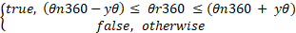 | (3)
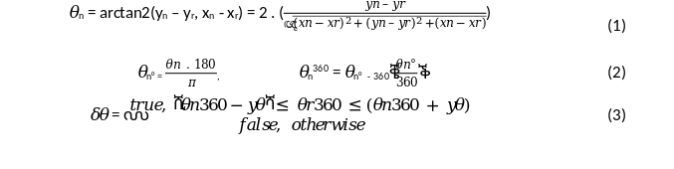

Linear Transition (𝛿𝑑) equation:
This equation calculates the change in position (linear displacement) of a robotic system from an initial position to a final position. Similar to the angular transition equation, the linear transition equation depends on various factors such as the initial and final positions, as well as the specific motion planning algorithm being used.

d_{n} (x_{n}, y_{n}) = | (4)
𝛿𝑑 = 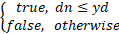 | (5)

where x_{n,} y_{n} are the current node coordinates,
x_{r,} y_{r} are the current robot coordinates,
𝜃_{n} is the calculated turn-to node n tangent angle (in radians),
𝜃_{n°} is 𝜃_{n} in degrees,
𝜃_{n}³⁶⁰ is 𝜃_{n°} in 0-360°,
y_{𝜃} is an angle threshold (in degrees),
d_{n} is the Euclidean distance,
𝛿𝜃, 𝛿𝑑 are the angular and linear state transitions.

Implementation
To implement the odometry model, we initially define the desired waypoints 𝑛1 to n5​ that the robot must traverse. Commencing from the starting node 𝑛𝑖 where i = 0, we ascertain the requisite orientation 𝜃𝑛​ to reach desire node utilizing the arctan2 function. As depicted in Equation below, determining 𝜃𝑛​ necessitates the current position of the robot (𝑥𝑟, 𝑦𝑟).
Subsequently, two action types are delineated: MOVE and TURN. In the event of a "TURN" action, the robot executes a spot turn by rotating its wheels at equivalent speeds but in opposing directions. It's imperative, however, to choose the optimal turning direction by selecting the shortest path.
To determine the turning direction, whether clockwise or counterclockwise, we compute the disparity between the node orientation 𝜃𝑛360​ and the robot's orientation 𝜃𝑟360​. This disparity is then standardized to an angle within the range of -180º and 180º. If the disparity exceeds zero, the robot turns counterclockwise (to the left); otherwise, it turns clockwise (to the right).

Given the robot's utilization of a differential drive, this objective is accomplished by altering the velocity direction independently on each wheel.
(6)
(7)
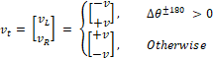
(8)

The velocity of the robot, denoted as 𝑣t​, is determined alongside the wheel velocities on the left (𝑣𝐿​) and right (𝑣𝑅​) wheels. Equation 8 aids in ascertaining whether the requisite angular orientation to reach node n has been attained. Upon achieving the desired orientation, the robot ceases turning, transitioning its action to MOVE.
During the MOVE action, the robot advances in a straight trajectory at a designated speed until the specified conditions in Equation 4 indicate the attainment of the target node. Upon meeting these conditions, the robot halts, shifts focus to the subsequent node in the waypoint list, and updates the action to TURN, facilitating the reorientation of the robot towards the succeeding node.
This iterative process persists across all predetermined waypoints, culminating in the transition to target tracking once the final node (n5) is reached.

Results:
- Successful waypoint navigation with minimal deviation.
- Its possibility to adapt to changes in terrain and environmental conditions.

- Target Tracking for Approach

The target tracking is the ability that enables the robot to identify, follow, and approach detected moving or constant targets, particularly essential in scenarios where the robot needs to interact with or reach a specific object or location. This vision-based method utilizes a colour blob selected by the user for tracking, with the blob colouring algorithm returning the centre of mass of the detected blob as image coordinates 𝑥𝑐, 𝑦𝑐. The tracker facilitates the robot to identify the object within three horizontal segmented regions in the image, follow by turning and moving the robot towards the target, and approach by moving towards the target and stopping at a safe distance. The mathematical notation of how the tracking method is composed, with the vector 𝐯𝑡 updated with the wheel velocities used to turn and drive the robot towards the target.

Approach Vector v_{a}:

The approach vector refers to the direction in which the robot moves towards the target. It represents the desired direction of motion to reach the target.

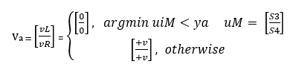
(9)

Tracking Vector v_{t}:
The tracking vector is referred to as the tracking error vector, represents the difference between the actual position of the target and the position that the robot is attempting to maintain relative to the target.

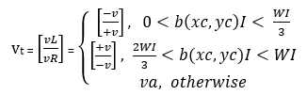

(10)

where v_{L,} v_{R} (v) are the robot left and right wheel velocities,
u_{M} is the middle ultrasonic sensor vector containing 2 sonars,
y_{a} is a range threshold (in millimetres),
I is the image matrix,
W_{I} the width size of the matrix I,
b the detected blob in the matrix I, xc, yc,
the centre coordinates of the blob b,
v_{a} is the approach vector,
v_{t} is the tracking vector.

Implementation:
To implement the target tracking model, a camera serves as the vision sensor, with the color blob detection algorithm sourced from OpenCV. And by introducing a 30-second delay, the robot allows users to select the desired color through the color tracker GUI. Upon transitioning from odometry to tracking mode, the robot initiates by scanning the left image zone for the blob. Should the blob be detected within this region, the robot executes a left turn; conversely, if located in the right image zone, it turns right. In the event that the blob is situated in the middle zone, the robot advances forward, approaching the target. Subsequently, it utilizes the two foremost ultrasonic sensors to identify objects and maintain a safe distance. Users then guide the robot towards its destination, 𝑛6.
However, in the absence of a detected blob, the robot endeavors to search for the target within its environment while evading obstacles.

Results:
- Efficient tracking of moving or stationary targets.
- Smooth and obstacle-aware approach strategies.

- Obstacle Avoidance
Obstacle avoidance is a function of the robot’s current or recent sensor readings and its goal position and relative location to the goal position. It is a critical behaviour for navigating in cluttered and dynamic environments, requires the robot to detect obstacles, plan alternative paths, and execute manoeuvres to avoid collisions. The eight forward-facing ultrasonic sensors on the pioneer P3DX mobile robot are used in our approach to measure the distance between objects and the robot. This obstacle handling method utilizes the robot's sonar ring, consisting of 8 ultrasonic range sensors with a range of 10-5000mm, to detect and avoid various types of obstacles such as furniture, walls, and people. The sensors’ positions are shown in Figure 1 below. The angular difference between the lines of sensors 0 and 1, sensors 6 and 7 are both 40ᵒ; while for the rest, the difference between two sensors is 20ᵒ. The avoidance algorithm enables the robot to identify and turn away from obstacles, decollide by identifying and escaping collisions, and untrap by identifying and escaping corner traps.

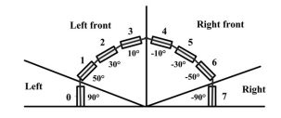

Figure 1. Ultrasonic sensors layout on the P3DX.

The mathematical notation of how the avoidance method is composed, with vectors 𝐯𝑎, 𝐯𝑐, 𝐯𝑢 updated with the wheel velocities used to turn and free the robot from obstacles, collisions, and corners.

Collision Vector v_{c}:
The collision vector represents the direction and magnitude of the force or movement that would result in a collision with an obstacle.

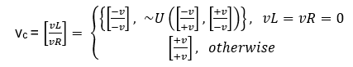

(11)

Avoidance Vector v_{a}:
The avoidance vector represents the desired direction and magnitude of movement to steer the robot away from obstacles and safely navigate around them.
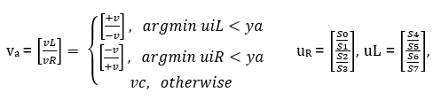

(12)

Untrap Vector v_{u}:
The untrap vector is used to escape from situations where the robot becomes trapped or stuck, such as when it encounters a dead end or gets wedged between obstacles.
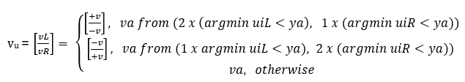

(13)

where ~U is a set of two randomly chosen velocity vectors [-v, +v]^{T} and [+v, -v]^{T}
u_{L}, u_{R} are the left and right side ultrasonic sensor vector each containing 4 sonars,
v_{a} from (2 x (arg_{i}min u^{i}_{L} < y_{a}), 1 x (arg_{i}min u^{i}_{R} < y_{a})) validates whether the left ultrasonic detected twice and the right ultrasonic vector detected once,
v_{c}, v_{a}, and v_{u} are the collision, avoidance, and untrap vectors respectively.

Implementation:
To implement the obstacle avoidance model, initial sensor readings are obtained from both the left and right sides. Subsequently, two key determinations are made on each side: identifying the minimum sensor reading and tallying the number of readings falling below the threshold. With these data in hand, the implementation of three avoidance strategies ensues.
Firstly, a check for a trapped state is conducted, characterized by both sides registering minimum sensor readings below the threshold. Guided by the conditions outlined in Equation 9, the robot executes the necessary maneuver. Conversely, when not ensnared in a trapped state, the avoidance strategy is invoked to scrutinize sensor readings for values below the threshold. Should this not be the case, the decollide strategy, as defined in Equation 10, is employed.
Furthermore, a special case for the untrap strategy is incorporated, triggered when an equal number of sensor readings below the threshold are detected on both sides. In such instances, the decollide strategy serves as a temporary solution to address this state

Results
- Successful navigation in environments with static and dynamic obstacles.
- Prompt and decisive responses to unexpected obstacles.

Code Explanation

The Steps involved to achieve the three crucial behaviors of main functionalities in the code:

- Odometry Model for Waypoint Following:

The odometry model is responsible for navigating the robot towards specified waypoints. Here's the breakdown of steps involved:

- Initialization: Initialize the robot's position and orientation.
- Navigation towards Waypoints:
    - Check if the robot is not already in motion (!omFlag).
    - If not in motion, set omFlag to true to indicate that the robot is moving.
    - Execute the navigation towards the specified waypoint.
- Checking for Completion:
    - If the navigation is completed, stop the robot's motion.
    - Shutdown the robot if the navigation is completed successfully.
- Thread Management:
    - Continuously update the robot's position using the odometry model in a separate thread.

- Target Tracking for Approaching Detected Targets:
The target tracking behaviour involves locating and approaching detected targets. Here are the steps:

- Checking for Stopping Conditions:
    - Check if there's a need to stop the robot's motion.
    - If the stopping condition is met, shut down the robot and exit the program.
- Target Tracking:
    - If the robot is not stopped, attempt to track the target.
    - If successful in tracking the target, continue tracking.
    - If unable to track the target, switch to obstacle avoidance behaviour.
- Thread Management:
    - Continuously update the tracking behaviour in a separate thread.

- Obstacle Avoidance:
Obstacle avoidance ensures the robot manoeuvres around obstacles in its path. Here are the steps:

- Checking for Stopping Conditions:
    - Check if there's a need to stop the robot's motion.
    - If the stopping condition is met, shut down the robot and exit the program.
- Avoiding Obstacles:
    - If unable to track the target or encountering obstacles, execute obstacle avoidance behaviour.
    - Adjust the robot's path to avoid obstacles while maintaining the intended direction.
- Thread Management:
    - Continuously update the obstacle avoidance behaviour in a separate thread.

Overall, these features effectively allow the robot's ability to efficiently move towards designated waypoints, accurately track objects, and successfully avoid obstacles. The code structure guarantees continuous monitoring and adjustments of the robot's behaviours in response to the surroundings and detected targets/obstacles.

The application software employed during the experimental proceedings.
The following software’s were employed during the experiment:
- IDE: IntelliJ IDEA Community Edition:
It serves as the primary Integrated Development Environment (IDE) in the experimental proceedings, known for its robustness and versatility in Java and Kotlin development. Its suite of features enhances productivity, with an intuitive interface and powerful code editing capabilities enabling efficient coding. Intelligent code completion, refactoring tools, and version control integration streamline development, allowing researchers to focus on innovation. The IDE's extensibility via plugins accommodates project-specific needs, supported by a vibrant community and comprehensive documentation. Its open-source nature promotes transparency and accessibility, aiding cost-effective project management. In conclusion, IntelliJ IDEA Community Edition is an indispensable tool empowering researchers in robotics and beyond.
- Mobile Sim:
MobileSim Simulator Software is integral to the experimental software suite, crucial for engineers, especially in robotics. Tailored for mobile robot testing and simulation, it enables precise assessment and improvement of system performance. Engineers utilize it to create realistic virtual environments, ensuring thorough analysis without physical constraints. Navigation algorithms, sensor configurations, and obstacle avoidance strategies are tested and optimized in this controlled setting. Features like customizable environments and realistic sensor models enhance experimentation, while its user-friendly interface streamlines the process. MobileSim empowers engineers to refine mobile robot designs efficiently, advancing innovation in robotics with precision and efficacy
- Mapper3:
Mapper3 is a pivotal software tool, specializing in computer graphics and 3D data analysis. It manipulates data for real-time mapping and rendering of complex scenes. Its versatility spans engineering, gaming, simulation, and scientific visualization, creating immersive experiences. Mapper3 employs advanced algorithms to translate data into 3D representations, aiding in complex structure visualization, enhancing gaming environments, and facilitating scientific exploration. Its real-time capabilities allow interactive manipulation, empowering users to make informed decisions.
- Aria:
ARIA, ActivMedia Robotics' object-oriented robot control API written in C++, provides seamless client-side software for efficient management of robot servers, sensors, and effectors, offering versatility and flexibility for diverse robotics applications, with support for multi- and single-threaded operations and integration with Java and Python, making it accessible to a wide range of programmers and enabling close control of robots, along with the ability to deploy prepared robot-control software swiftly on ActivMedia Robotics' mobile robot platforms, complemented by various tools for robot programming and advanced navigation routines available in ARNL or SONARNL libraries, while also offering GUI capabilities through ArNetworking for server program creation and MobileEyes connection, ensuring a comprehensive resource for mobile robotics development and experimentation.
- Open CV:
OpenCV, an integral tool in the experimental toolkit, is an open-source computer vision library supporting C, C++, and Python. Its broad capabilities cover image and video processing, object recognition, and tracking, catering to diverse applications like industrial automation and augmented reality. Its strength lies in a dynamic user community, providing extensive documentation and support. Researchers and engineers leverage OpenCV for seamless integration of advanced computer vision features, from real-time object detection to complex data analysis. Its cross-platform compatibility ensures easy deployment across operating systems, enhancing accessibility. OpenCV's versatility and user-friendly interface propel innovation in computer vision research and application development within experimental contexts.
- JDK 7:
JDK 7, or Java Development Kit 7, serves as a cornerstone software development environment within the experimental proceedings, facilitating the creation of Java applications. Released on July 27, 2011, JDK 7 introduces numerous enhancements and features, notably improvements in garbage collection, concurrency, and expanded support for non-ASCII characters. This version of JDK is compatible with both Windows and Linux operating systems, offering versatility in deployment across various platforms, including desktop and mobile devices. Notably, JDK 7 enables developers to build Java applications for a wide range of environments, leveraging its capabilities for both backend server systems and client-side applications. Its minimum requirement of 1.5GB of RAM ensures efficient performance, making it an indispensable tool for Java development within the experimental framework.
7. FTDI Driver:
The FTDi driver plays a vital role in experimental proceedings, enabling seamless communication between computers and USB-connected device which is the mobile robot Pioneer P3-DX through the FTDI protocol. Supporting various converters like USB-to-serial, parallel, and IEEE 1394, it ensures efficient data transfer and device control. Typically, the driver installs automatically upon USB device connection, ensuring hassle-free operation. Alternatively, users can manually download and install it from the manufacturer's website for greater control. With its reliability and widespread adoption, the FTDi driver serves as a crucial link in facilitating interactions between computers and USB devices, contributing to smooth experiment execution and data collection.

- Results and Conclusion
Recorded values from the experiment taken during the Odometry and Tracking phases below
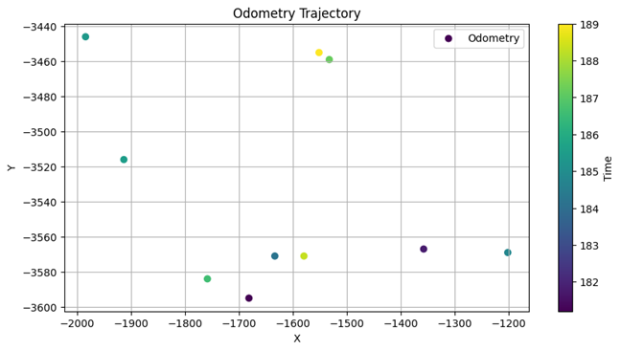
Table 1: Pre-recorded values from n1 to n6.

 | Odometry (mm)
N | X | Y
1 | 2130 | 0
2 | 2130 | -2320
3 | 3970 | -2320
4 | 3970 | -3630
5 | -1900 | -3600
6 | -3137 | -266

Table 2: Experimental table for the Odometry phases.

Samples | Odometry (mm) (n5) |  | Euclidean | Time (sec)
# | X | Y | d(x,y) | t
1 | -1681 | -3595 | 219.06 | 181.2
2 | -1913 | -3516 | 85.00 | 185.5
3 | -1758 | -3584 | 142.90 | 186.6
4 | -1532 | -3459 | 394.09 | 187.2
5 | -1579 | -3571 | 322.31 | 188.3
6 | -1984 | -3446 | 175.42 | 185.4
7 | -1633 | -3571 | 268.57 | 184.2
8 | -1357 | -3567 | 544.00 | 181.8
9 | -1201 | -3569 | 699.69 | 184.8
10 | -1551 | -3455 | 377.92 | 189
Mean (μ) | -1618.9 | -3533.3 | 322.90 | 185.4
Standard Deviation (σ) | 223.6477 | 55.85884 | 179.84 | 2.42

Table 3: Experimental table for the Tracking phases.

Samples | Tracking (mm) (n6) |  | Euclidean | Time (sec)
# | X | Y | d(x,y) | t
1 | -3051 | -223 | 96.15 | 117.6
2 | -3042 | -221 | 105.12 | 118.8
3 | -3137 | -266 | 94.63 | 114.7
4 | -3752 | -638 | 718.76 | 110.8
5 | -3504 | -81 | 93.62 | 180.3
6 | -3054 | -201 | 105.42 | 113.2
7 | -3064 | -203 | 96.43 | 115.2
8 | -3047 | -308 | 99.32 | 112.8
9 | -3083 | -186 | 96.52 | 113.8
10 | -3593 | -413 | 479.11 | 112.2
Mean (μ) | -3232.7 | -274 | 198.51 | 120.94
Standard Deviation (σ) | 258.6349 | 146.2224 | 207.29 | 19.9188

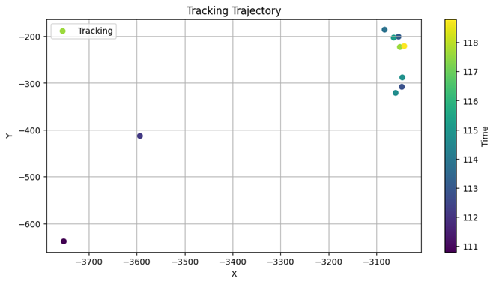

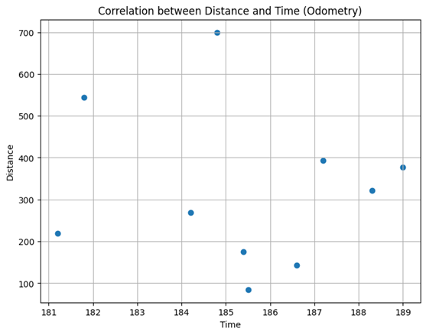

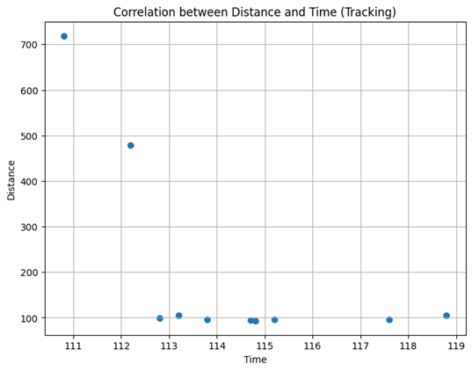

Odometry Phase:
Mean distance (d) = 322.90
Mean time (t) = 185.4
Standard deviation of distance (σ_{d}​) = 179.84
Standard deviation of time (σ_{t​}) = 2.42
Covariance (COV) Calculation:

Using the formula: (COV _{d,t}) =

COV _{d,t} = (1/10-1)[(219.06−322.90)×(181.2−185.4)+(85.00−322.90)×(185.5−185.4)+…+ (377.92−322.90)(189−185.4)]

COV _{d,t} = (1/9)[(−103.84)×(−4.2)+(−237.90)×(0.1)+…+(55.02)(3.6)]

COV _{d,t} = (1/9) [436.128+...+198.072]

COV _{d,t} = (1/9) × 179.48

COV _{d,t} ≈ 19.94

Using the formula:

ρ = 19.94 / (179.84 x 2.42)

ρ ≈ 19.94 / (435.2128)

ρ ≈ 0.04582

Odometry Phase Covariance (COV) = 401.1
Odometry Phase Correlation Coefficient (ρ) ≈ 0.921

Tracking Phase:
Mean distance (d) = 198.51
Mean time (t) = 120.94
Standard deviation of distance (σ_{d}​) = 207.29
Standard deviation of time (σ_{t​}​) = 19.92

Covariance (COV) Calculation:

Using the formula: =

COV _{d,t} = (1/10-1)[(96.15−198.51)×(117.6−120.94)+(105.12−198.51)×(118.8−120.94)+… +(479.11−198.51)(112.2−120.94)]

COV _{d,t} = (1/9) [(−102.36)×(-3.34)+(−93.39)×(-2.14)+…+(280.6)(−8.74)]

COV _{d,t} = (1/9) [(341.6624)+(199.795)+… +(-2454.924)]

COV _{d,t} = (1/9) × (−8794.8216)

COV _{d,t} ≈ − 997.2024

Using the formula: =
ρ = − 997.2024 / (207.29 x 19.92)
ρ ≈ − 977.2024 / 4129.22
ρ ≈ − 0.2366

Tracking Phase Covariance (COV) ≈ -977.2024
Tracking Phase Correlation Coefficient (ρ) ≈ -0.2367
In conclusion, the analysis of odometry and tracking phase covariance and correlation coefficients yields valuable insights into the performance and reliability of the respective systems. The odometry phase covariance of 401.1 indicates a moderate level of variability in the odometry measurements, while the high correlation coefficient of approximately 0.921 suggests a strong linear relationship between the measured and actual phases. Conversely, the tracking phase covariance of approximately -977.2024 signifies a significant level of variability in the tracking measurements, with a correlation coefficient of approximately -0.2367 indicating a weaker linear relationship compared to odometry. These findings underscore the importance of considering both covariance and correlation coefficients in assessing the accuracy and consistency of robotic navigation systems. Further research and refinement may be warranted to enhance the precision and robustness of these systems for real-world applications.

Challenges and Limitations Encountered During Experimentation
Several factors and challenges influence the performance of the Pioneer P3-DX robot:
- Characteristics of obstacles, such as their thickness and shape.
- Surface conditions of the floor or terrain traversed by the robot.
- Functionality and performance of the robot's components, including sensor accuracy and motor operation.
- In the determination of nodes or waypoints, it is essential to account for inherent errors in both the robot and its environment.
- Lighting conditions within the environment can impact the robot's perception and navigation capabilities.

- CONCLUSION
The research conclusively demonstrates that integrating the odometry model, target tracking, and obstacle avoidance significantly enhances the autonomy and operational safety of mobile robots. The implementation of these behaviors on the Pioneer P3-DX robot showed reliable performance in dynamic environments, validating the theoretical models with practical experiments. The study's findings contribute to the field of robotics by providing a robust framework for autonomous navigation that can be adapted for various industrial applications. Future work should focus on refining these behaviors through advanced algorithms and more real-world testing to address more complex navigation scenarios and further improve the adaptability and efficiency of autonomous mobile robots.
- References
- Siegwart, R., & Nourbakhsh, I. (2004). Introduction to autonomous mobile robots. MIT Press. https://mitpress.mit.edu/books/introduction-autonomous-mobile-robots-second-edition
- Abdullah, Q., Mohamad, M., et al. (2020). Real-time Autonomous Robot for Object Tracking using Vision System.
- Benavidez, P., & Mo, J. (2011). Mobile Robot Navigation and Target Tracking System.
- Chancharoen, R., & Sangveraphunsiri, V. (2002). Target tracking and obstacle avoidance for mobile robots.
- Chi-Wen Lo, Wu K., Lin Y., & Liu J. (2014). An Intelligent Control System for Mobile Robot Navigation Tasks in Surveillance.
- Huang, L., & Tang, L. (2008). Dynamic Target Tracking Control for a Wheeled Mobile Robots Constrained by Limited Inputs.
- Hwang, W., Park, J., et al. (2011). Mobile Robot Vision Tracking System Using Dead Reckoning & Active Beacons.
- Jung, B., & Sukhatme, G. S. (2005). Real-time Motion Tracking from a Mobile Robot.
- Luo, X., Zhang, D., & Jin, X. (2019). A Real-time Moving Target Following Mobile Robot System with Depth Camera.
- Pandey, A., Pandey, S., & DR, P. (2017). Mobile Robot Navigation and Obstacle Avoidance Techniques: A Review.
- Walead K., Alaa H. & Akhtar J. (2022). Monocular vision with deep neural networks for autonomous mobile robots navigation.
- Hjartarson, K. (2023, February 4). Dynamic Path Planning, mapping, and navigation for ... https://www.diva-portal.org/smash/get/diva2:1734693/FULLTEXT01.pdf
- Ben-Ari, M., & Mondada, F. (1970, January 1). Robotic Motion and odometry. SpringerLink. https://link.springer.com/chapter/10.1007/978-3-319-62533-1_5
- Lee, M.-F. R., & Lee, K. H.-E. (2013). Autonomous Target Tracking and following mobile robot. Journal of the Chinese Institute of Engineers, 36(4), 502–529. https://doi.org/10.1080/02533839.2012.731863
- Dos Reis, D. H., Welfer, D., De Souza Leite Cuadros, M. A., & Gamarra, D. F. (2019). Mobile Robot Navigation using an object recognition software with RGBD images and the Yolo algorithm. Applied Artificial Intelligence, 33(14), 1290–1305. https://doi.org/10.1080/08839514.2019.1684778
- Guo, X., Liu, H., & Dai, H. (2020). Mobile Robot Target Tracking System Based on Deep Learning. https://www.clausiuspress.com/conferences/ACSS/ESAC%202020/ESAC2020044.pdf
- Aria Overview. Aria: ARIA overview. (n.d.). http://www.cassinis.it/Siti%20ex%20Uni/ARL/docs/documentation/Aria%20documentation/Old%20and%20useless/ARIA%20docs/main.html

- APPENDICES
Link to the code:
https://drive.google.com/drive/folders/1b2eC8GPXccAh-HmDpnXM278fJ_h-qrz_?usp=sharing

